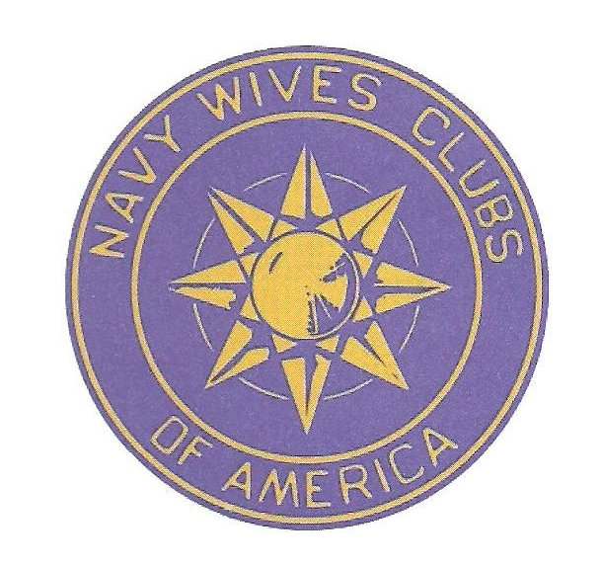
2017 – 2018 NWCA Merchandise, Order Form
_________________________________________________________________________________________

Name: ___________________________________________________ Date of Order: ___________________________________

Address: _________________________________________________ Telephone #: _____________________________________

City/State/Zip: ____________________________________________ Club Name & # or MAL: __________________________

Quantity Item/Size/Color(s) Price Each Extended Price

_____________ ________________________________________ __________ _____________

_____________ ________________________________________ __________ _____________

_____________ ________________________________________ __________ _____________

_____________ ________________________________________ __________ _____________

_____________ ________________________________________ __________ _____________

_____________ ________________________________________ __________ _____________

For Name Tags Only:

Name: ________________________________________________________
Print Name exactly as to be engraved on Name Tag

Club Name & Number or MAL or Member-at-Large: ________________ ______________________________________________________________
If no Club or MAL or Member-at-Large is to be engraved, leave blank

Other Instructions/Hangers:______________________________________
Subtotal _____________ Shipping & Handling: Flat Rate Envelope ……….Add $6.65 Shipping & Handling _____________
Small Flat Rate Box……...Add $7.15 _____________
Medium Flat Rate Box…..Add $13.60 _____________
Large flat Rate Box……...Add $18.95 _____________
(****) Insurance _____________
Name Tags……………… (****) _____________ Total _____________
(****) Contact National Merchandise Chairman prior to sending in your order for shipping
charge, or if Insurance is requested.

Send Order To: Kathy More
1224 Pompano Lane
The Villages, FL 32159-643
Email: nwcamerchandise@gmail.com
Phone: 352-633-9616 (h) or 90-945-8360 (c)

DO NOT WRITE BELOW THIS AREA
Date Received: ___________________ Check Amount: ______________ Receipt Number: _______________
Postage Paid: ____________________ Actual Postage: ______________ Date Shipped: __________________
Method of Shipment: _____________

Revised Sept 18, 2017
Please Print All Information
Page 1 of 2

2016 – 2017 NWCA MERCHANDISE PRICELIST
Merchandise Operational Supplies
#Bradford Journal Cover Set $ 14.00 Operating Manual - CD 2013 edition $ 5.00
#Canvas Zippered Tote Bag $ 20.00 Prayer Book - 2014 edition $ 8.00
(S) Cell Phone Wallets $ 2.50
Challenge Coin $ 10.00 Cards & Certificates
#Challenge Coin – Anchor $ 10.00
Credit Card Case Holders $ 8.00 (S) Gofer $ .15
Grave Marker - Brass - Medallion $ 25.00 (S) Honorary Membership Certificate $ .25
(S) Grocery Tote $ 2.00 (S) Initiation Certificate $ .25
#Junior Pad Folio $ 20.00 (S) Installation Certificate $ .45
NWCA 1” Aluminum Disk/adhesive $ 1.75 Local Club Chairman Card $ .20
NWCA 2” Aluminum Disk/adhesive $ 2.25 Local Club Officer Card $ .20
NWCA 3” Aluminum Disk/adhesive $ 4.50 (S) Member Sponsoring Certificate $ .10
#NWCA Official Gofer Ball Cap $ 15.00 Membership Cards $ .35
(S) Recognition Certificate $ .25
NWCA Mylar Emblem - 1 ½” 25/$ 3.00
NWCA Mylar Emblem - 1 ½” 100/$ 12.00 (S) Sample Kit:
(S) NWCA Mylar Emblem - 2” $ .75
Ornament Plaque - Contains 1 (one) of each of the below $ 6.75
Georgia Marble NWCA $ 10.00 listed Certificates, Cards and Stationary Items:
Pad Folio - Debossed $ 30.00 - Certificate of Appreciation - Installation Certificate
Patch - Cloth $ 3.50 - Gift Certificate - Letterhead
Patch - Heat Transfer - Blue and Gold $ 2.50 - Gofer Card - Letterhead Envelope
Patch - Heat Transfer - White $ 2.50 - Honorary Membership Certificate - Local Club Chairman Card
#Patriotic Luggage Tag $ 2.00 - Informal Card w/envelope - Local Club Officer Card
(S) Pen – Stylus Blue w/Silver Trim $ 2.50 - Initiation Certificate - Membership Card
# Pen – Stylus Blue w/Gold Trim $ 2.50 - Recognition Certificate
Ribbon - (Blue & Gold - 1 Yard set) $ 2.50 Blue and Gold Name Badge
Ribbon - Pre-sewn 6” $ 1.00
Ribbon - Pre-sewn 9” $ 1.25
Ribbon - Pre-sewn 12” $ 1.50 Name Badge Hangers only, w/engraved Title or Office $ 4.00
#Special Occasion Cards, 20 cards, 20 envelopes $ 10.00 **Name Badge with 1 pin $ 7.50
#Tumbler – 24oz. $ 12.00
Umbrella $ 10.50 **Name Badge with 2 pins $ 9.00
#Window Cling $ 8.00 **Name Badge with a magnet $ 12.75
#Zip Pocket Cinch Bag $ 8.00 **Name Badge with a pin & magnet $ 13.25
(S) Zipper Bottle Koozie $ 1.50 **Notes: Cost of Name Badges, above, includes 2 lines of engraving only.
Line 1 includes Club Name or MAL designator and Line 2 includes
Pins Member Name. For Title or Office engraving on a Name Badge
#American Flag $ 4.00 hanger, cost is an additional $4.00.
Coast Guard Cap $ 4.00
White Hat $ 4.00 Special Notes:
Marine Garrison Cap $ 4.00 (1) Charter Member Certificates are not for sale. Application must be
Enlisted Hat $ 4.00 requested through the NWCA Secretary as per SR #12-10/95.
Lone Sailor (Gold) $ 9.00 (2) (S) Indicates current items now on Sale, until item is completely sold.
Lone Sailor (Pewter) $ 9.00 (3) (#) Indicates New Items to Inventory.
#NWCA Official Flag Pin $ 4.50 (4) ALL SALES FINAL 30 DAYS FROM SHIPPING. National
Merchandise Chairman must be notified of any discrepancies or
damage upon receipt of your order.
Gift Certificates: Certificates are available in any amount. (5) Authorization required for credit prior to return of order.
Each certificate is printed on attractive card stock with
the NWCA emblem in the center. Certificates may be Send all inquiries and order to:
redeemed for any NWCA merchandise. Kim Rumbo, NWCA Merchandise Chairman
40 County Road 34775
Paris, Texas 75460
Email: 98mi_KtexC@hughes.net Phone: 903-905-2653 or 903-905-3522
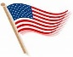
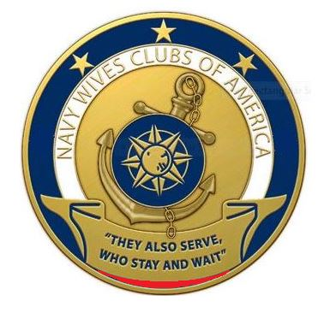
“Friendship and Dedication” Page 2 of 2 Revised Sept 18, 2017

